|  |
| --- |
| **JDN Standards – Time Server v1.1** |

Introduction 1

Configuration 1

Cabling 2

# Introduction

We currently use the Meinberg LANTIME M300 GLN time server as our primary time source.

This server is 1U and contains an internal oscillator which can provide accurate time readings, even if no external source is available. Ideally, the time server should never operate without external sources to validate its internal clocks against.

The most important time source is its antenna. It is capable of using both GPS and Glonass satellites for accurate time readings.

If not enough satellites are providing a reliable signal, the server will fall back on the NTP server at JDN Aalst. Optionally, additional internet NTP servers can be included.

# Configuration

* Unbox the time server.
* Power it up.
* Configure LAN 3 through the touch interface (pick a local address, like 192.168.1.1/24), do not use LAN 0 or LAN 1.
  + Network > Interfaces > LAN 3 > OK > IPv4
* Directly connect your laptop to LAN 3 and configure an adjacent address (For example 192.168.1.2/24).
* Surf to the web interface.
* Log in using username: root & password: timeserver.
* Under “System” > “Firmware/Software Update”
  + Update the firmware to 6.24.005.  
    This firmware can be found under :  
    \\jdn-file01\Ict_New_Standard_Sites_Vessels\Firmware\Current\Meinberg M300 LANTIME\Current

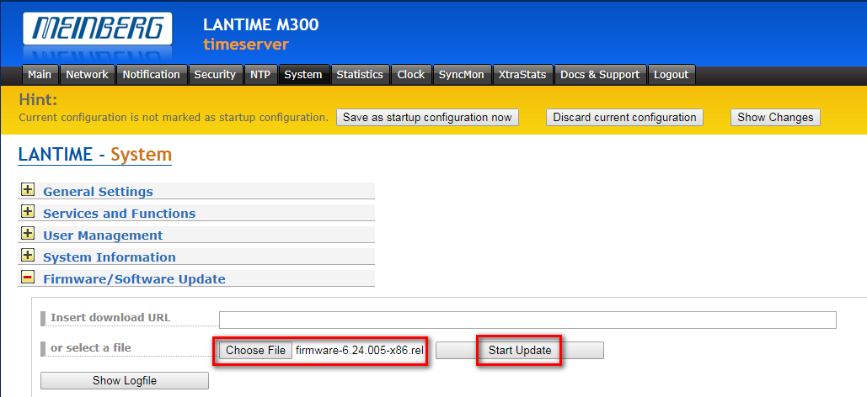

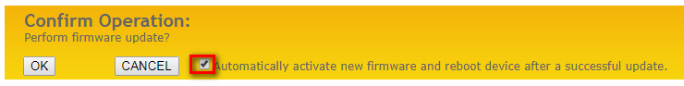

* + Upload the JDN config under “System > Configuration & Firmware Management”.   
    \\Jdn-file01\ict_new_standard_sites_vessels\Resources\Meinberg LANTIME M300\Current and apply the configuration.

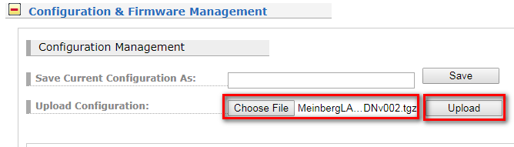

* After the upload, you still need to activate your configuration!

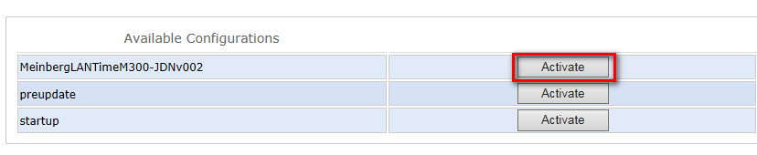

* Configure your laptop with the fixed IP address in the 172.16.3.x range and connect the cable on LAN 0 or LAN 1 interface of the Meinberg.  
  Log in to the web interface on <http://172.16.3.22> , using credentials “root” & “EMEya539Es!”
* Under “Network” > “Main Network Information”, modify:
  + Host name
  + Domain
  + Name server 1 (DNS server of ship/site X.X.X.11)
* Under “System” > “General Settings”, modify:
  + Location
  + User Management > User Administration > Change Passwords

Select “Change Current User Password” and modify the password in the password you generated before.

* + Go to user list an delete the Users adl_local and adl_tse.
  + Select Create User and create adl_local (Admin User) and adl_tse (Super User) with their corresponding passwords.
* Under “Notification” > “Email Information”, edit the initials of your ship:
  + Recipient
  + Sender
  + Smarthost
* When all is configured , click on “Save as startup configuration now” to save all the settings to the startup.
* Select System > Services and functions > Reboot device   
  This will reboot the Meinberg and confirm to reboot.

# Cabling

* When all the configuration done you can connect the time server to the switches.

The ports used are LAN 0 and LAN 1, corresponding to the switch layout template. (Xls)